Common SDTM Variables
Crash course in CDISC SDTM variables

Rules
- All raw variables
- Add any required SDTM compliance variables, ex. Topic
- Use VDT as metadata for variable attributes
- No user defined formats applied
- Apply formula for common SDTM variables
- Most all datasets, except DM, are vertical structure
- Common key variables : USUBJID, XXTESTCD, XXDTC, XXCOD

Hierarchy of Grouping Variables
STUDYID/DOMAIN
XXCAT, ex. Behavior Rating
XXSCAT, ex. Parent Form
USUBJID
XXGRPID
XXTESTCD, ex. BRFP111
XXTEST, ex. ITEM1

STUDYID/USUBJID/DOMAIN – PKV016/XXXXXX-XXXX-XXXX/QS

studyid = 'XYZ123';
domain = 'LB';
usubjid = strip(uniqueid);

XXSEQ – SEQ # by key variables

proc sort data=ex;
by usubjid exstdtc;
run;

data ex;
set ex;
by usubjid exstdtc;
if first.usubjid then exseq=1;
else exseq + 1;
run;

XXTESTCD/XXTEST – Coded value/Formatted value [$XXTESTCD., $XXTEST.]

lbtest = put(labtest, $lbtest_labs_labtest.);
lbtestcd = put(labtest, $lbtestcd_labs_labtest.);

XXCAT/XXSCAT – Category/Subcategory

lbcat = put(labcat,$lbcat_labs_labcat.);

XXORRES/XXSTRESC/XXSTRESN – Original result/$ Standard Unit/ N Standard Unit [BEST.]

**** store original results;
lborres = strip(put(nresult, best.));
lborresu = strip(colunits);

lbornrlo = strip(put(lownorm, best.));
lbornrhi = strip(put(highnorm, best.));

**** create standardized results;
lbstresc = lborres;
lbstresn = nresult;
lbstresu = lborresu;

lbstnrlo = lownorm;
lbstnrhi = highnorm;

XXDTC – Date/Time [YYYY-MM-DD, ISO 8601]
Process ISO8601 Date/Time as a SAS date variable – INPUT(SVSTDTC, E8601DA.)

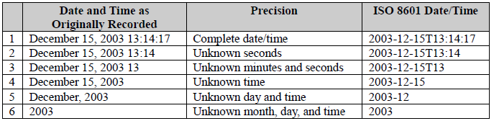

if (&second ne .) then
&dtcdate = put(&year,z4.) || "-" || put(&month,z2.) || "-"
|| put(&day,z2.) || "T" || put(&hour,z2.) || ":"
|| put(&minute,z2.) || ":" || put(&second,z2.);
else if (&minute ne .) then
&dtcdate = put(&year,z4.) || "-" || put(&month,z2.) || "-"
|| put(&day,z2.) || "T" || put(&hour,z2.) || ":"
|| put(&minute,z2.);
else if (&hour ne .) then
&dtcdate = put(&year,z4.) || "-" || put(&month,z2.) || "-"
|| put(&day,z2.) || "T" || put(&hour,z2.);
else if (&day ne .) then
&dtcdate = put(&year,z4.) || "-" || put(&month,z2.) || "-"
|| put(&day,z2.);
else if (&month ne .) then
&dtcdate = put(&year,z4.) || "-" || put(&month,z2.);
else if (&year ne .) then
&dtcdate = put(&year,z4.);
else if (&year = .) then
&dtcdate = "";

** remove duplicate blanks and replace space with a dash;
&dtcdate = translate(trim(compbl(&dtcdate)),'-',' ');

XXDY – Study Day based on first dose date, if visit date is after dose date then add 1, else do not.
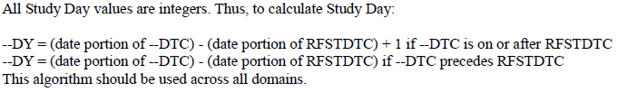

Option # 1
case
when a.qsdtn > . and b.fdosedt > . and a.qsdtn >= fdosedt then (datepart(qsdtn)-datepart(fdosedt) + 1)
when a.qsdtn > . and b.fdosedt > . and a.qsdtn < fdosedt then (datepart(qsdtn)-datepart(fdosedt))
else .
end as qsdy

Option # 2
if length(&date) >= 10 and length(&refdate) >= 10 then
do;
if input(substr(%substr("&date",2,%length(&date)-3)dtc,1,10),yymmdd10.) >=
input(substr(%substr("&refdate",2,%length(&refdate)-3)dtc,1,10),yymmdd10.) then
%upcase(%substr("&date",2,%length(&date)-3))DY = input(substr(%substr("&date",2,%length(&date)-3)dtc,1,10),yymmdd10.) -
input(substr(%substr("&refdate",2,%length(&refdate)-3)dtc,1,10),yymmdd10.) + 1;
else
%upcase(%substr("&date",2,%length(&date)-3))DY = input(substr(%substr("&date",2,%length(&date)-3)dtc,1,10),yymmdd10.) -
input(substr(%substr("&refdate",2,%length(&refdate)-3)dtc,1,10),yymmdd10.);
end;

VISITNUM/VISIT/VISITDY – Visit #/Label/Day [$VISLIST]
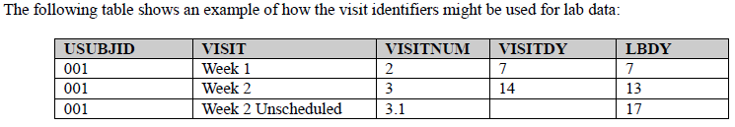

visitnum = month;
visit = put(month, visit_labs_month.);

XXBLFL – Baseline flag [N, Y, ] based on visits before or on first dose date, i.e. study day <= 1

Option # 1
* Sort by study variable, LBDY, at the end;
proc sort data=lb4;
by usubjid lbcat lbtestcd lbspec lbmethod visitnum lbdy;
run;

* Create phase variable based on acceptable study day values;
data lb5;
set lb4;
by usubjid lbcat lbtestcd lbspec lbmethod visitnum lbdy;
if lbdy <= 1 then phase = 0; else phase = 1;
run;

* Sort by study variable, LBDY, and PHASE at the end;
proc sort data=lb5;
by usubjid lbcat lbtestcd lbspec lbmethod visitnum lbdy phase;
run;

Add new baseline flag variable, LBBLFL, based on LAST.PHASE and PHASE=0;
data lb6;
set lb5;
by usubjid lbcat lbtestcd lbspec lbmethod visitnum lbdy phase;
if last.phase and phase = 0 then lbblfl = 'Y'; else lbblfl='';
drop phase;
run;

Option # 2a
* Sort with the study day variable, QSDY at the end;
proc sort data=adhdt;
by usubjid qscat qsscat qstestcd qsdy;
run;

* Group without the study day variable, QSDY. Create baseline flag variable, QSBLFL;
proc sql;
create table bflag as
select usubjid, qscat, qsscat, qstestcd, min(qsdy) as bflagdy, ‘Y’ as qsblfl
from adhdt where qsorres ne '' and . < qsdy <=1
group by usubjid, qscat, qsscat, qstestcd;
quit;
proc print data=bflag (obs=200);
where usubjid='PKU016-0123-1004'; run;
proc freq data=bflag;
tables usubjid*qscat*qsscat*qstestcd*qsdy*bflagdy/list missing;
run;

* Many to One join with the study day variable, QSDY, and the baseline flagged study day variable, BFLAGDY. Add new baseline flag variable, QSBLFL;
proc sql;
create table adhd2 as
select a.*, b.qsblfl
from adhdt as a left join bflag as b
on a.usubjid=b.usubjid and a.qscat=b.qscat and a.qsscat=b.qsscat and a.qstestcd=b.qstestcd and a.qsdy=b.bflagdy;
quit;

Option # 2b
* Sort with the study day variable, QSDY at the end;
proc sort data=adhdt;
by usubjid qscat qsscat qstestcd qsdy;
run;

* Group without the study day variable, QSDY.
proc sql;
create table bflag as
select usubjid, qscat, qsscat, qstestcd, min(qsdy) as bflagdy
from adhdt where qsorres ne '' and . < qsdy <=1
group by usubjid, qscat, qsscat, qstestcd;
quit;
proc print data=bflag (obs=200);
where usubjid='PKU016-0123-1004'; run;
proc freq data=bflag;
tables usubjid*qscat*qsscat*qstestcd*qsdy*bflagdy/list missing;
run;

* Create baseline flag variable, QSBLFL;
* Many to One join. If study day variable, QSDY, matches the baseline flagged study day variable, BFLAGDY, then set the new baseline flag variable, QSBLFL, to ‘Y’. All other non-matching records are set to missing;
proc sql;
create table adhd2 as
select a.*,
case
when qsdy = b.bflagdy then 'Y'
else ''
end as qsblfl
from adhdt as a left join bflag as b
on a.usubjid=b.usubjid and a.qscat=b.qscat and a.qsscat=b.qsscat and a.qstestcd=b.qstestcd;
quit;

Option # 3
if visit = 'Baseline' then lbblfl = 'Y';
else lbblfl = ' ';

XXTERM/XXDECOD – Original Verbatim/Standard Value
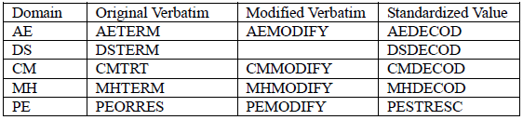

Common SUPPXX SDTM Variables

Common key variables: RDOMAIN, USUBJID, IDVAR, IDVARVAL, QNAM

STUDYID/USUBJID/RDOMAIN – PKV016/XXXXXX-XXXX-XXXX/QS

IDVARVAL = XXSEQ, used to link with XXSEQ in XX dataset

IDVAR = ‘XXSEQ’, name of variable to link with XXSEQ variable [$IDVAR.]

QNAM = Coded name [$LBQNAM.]

QLABEL = Formatted Label [$LBQLABEL.]

QVAL = Original Value

QORIG = Source of data (CRF, Derived, Assigned) [$QORIG.]

QEVAL = Subjective Results [$QEEVAL.]

data suppex;
length idvar $8 idvarval $3 qnam $8 qlabel $40 qval $200 qorig $10 qeval $30;
set suppex;

idvar='EXSEQ';
idvarval=strip(put(EXSEQ, best6.));
qorig='CRF';
qeval='INVESTIGATOR';

if exdoswt ne . then do;
qnam='EXDOSWT';
qlabel='Dosing weight (kg)';
qval=strip(put(exdoswt, best12.));
output;
end;
run;

